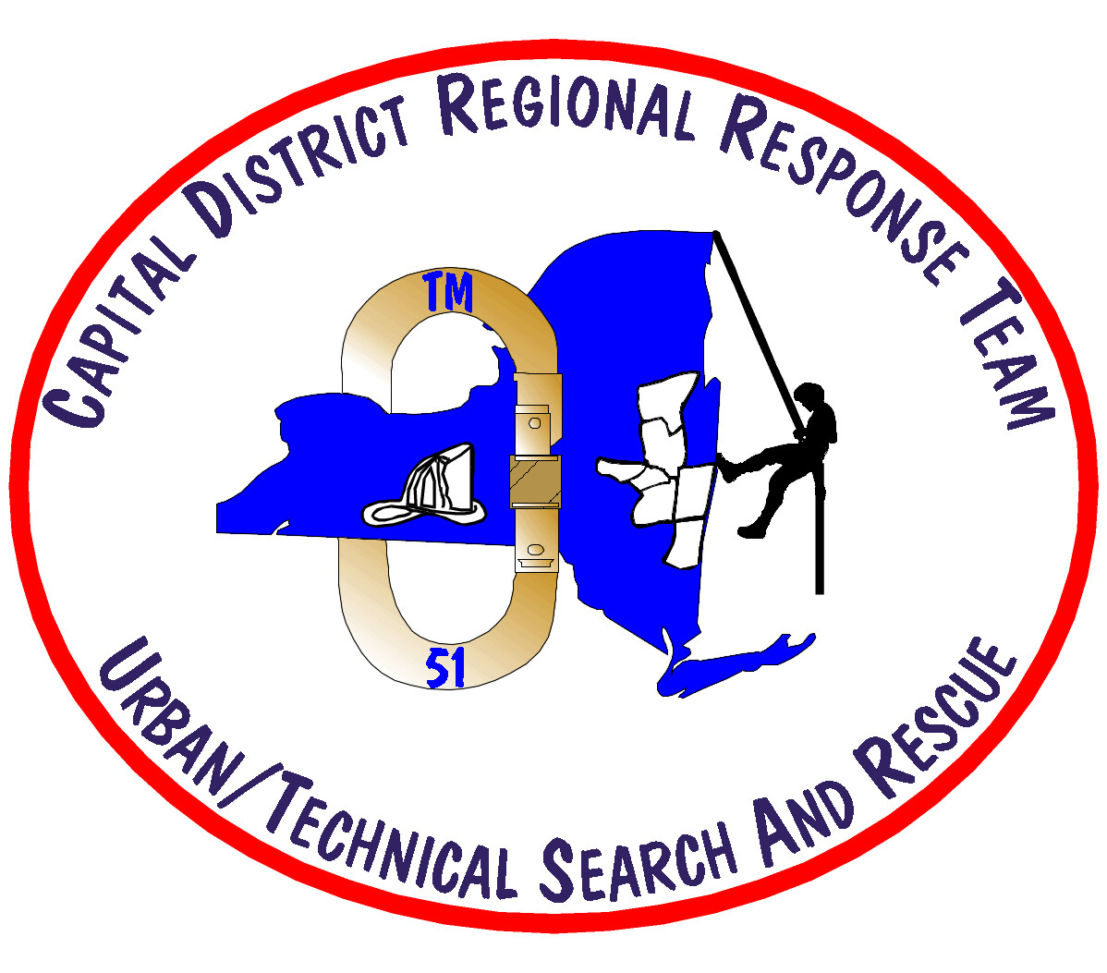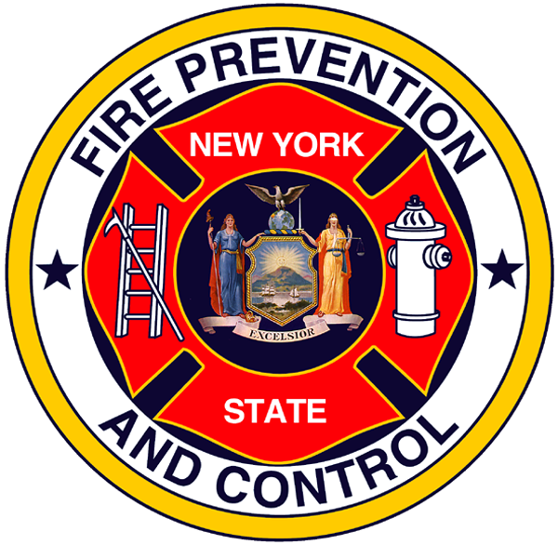

State of New York
Department of State
Office of Fire Prevention and Control
New York Task Force 2

NY-TF2 Application Package

Dear Applicant:

Thank you for your interest in becoming a Member of New York Task Force 2 . This is a volunteer Urban Search and Rescue Team that is authorized by the Governor of the State of New York under Executive Order #43 of September 1996.

NY-TF2 conforms to U/TSAR Operational Procedures that were developed by FEMA. NY-TF2 is a response team comprised of three major functional elements: Rescue, Medical, and Technical, including associated supervisory positions.

Members of the NY-TF2 Selection Committee will review your application and all of the attached documents. Your application package will be reviewed for training and certification suitable to your prospective assignment to the Team.

The Selection Process will take into consideration the following requirements:
Applicant submits a completed NY-TF2 Application Package
Applicants must have Memorandum of Understanding signed and attached. (Applications will be accepted without Memorandum of Understanding however it will be required for final appointment.)
Applicant submits medical authorization
Applicant submits completed Authorization to Participate in the U/TSAR Physical Agility Test Form with Physician certification
Applicant successfully passes the U/TSAR Physical Agility Test
Applicant successfully passes the application review by the Selection Committee
Applicant successfully passes an oral interview
Applicant must have certification that he or she is medically cleared to wear a full face respirator for extended periods of time

Attach copies or originals of the following: (check as appropriate)
Valid New York State motor vehicle license required
Current CPR/First Responder Certificate required
Resume describing any suitable experiences required
Three letters of reference including contact information and relationship required
A short letter detailing your goals, interests and experiences relating to search and rescue required
Candidate Physical Ability Test (CPAT) certification if already completed (required for Rescue Specialist, Rescue Squad Officer, Rescue Team Manager, and Medical Specialist within 12 months of appointment to such positions)
Copy of sponsoring agency fit test (Scott mask preferred) and physical (if available)
EMT/Paramedic/MD license or certificates of training
Engineering Certificate if you are a structural engineer
Law enforcement related education and training certificates (where appropriate)

Other Requirements for Membership:
- New York State Resident
- 21 years of age
- Minimum 2 years career or 4 years active volunteer service within the sponsoring agency or agency type
- Completion of the basic level required training for the team position assigned within 18 months from date of appointment
- Must be available for a minimum of 40 hours of team training per year and 20 hours of administrative/cache hours (meetings, inventory, equipment maintenance, etc.)
- Member must live and work in an area where he/she can respond to the team headquarters building, fully prepared for deployment, within 90 minutes of activation. Member must also be available for an initial response deployment of 48 to 72 hours.

Applications shall be accepted and reviewed without discrimination on the basis of the applicant’s race, creed, color, sex, age, national origin, ancestry, marital status or physical handicaps.

Applications will be accepted at any time. The Executive Board will only review and vote on new members at the May and November Board meetings.

Complete this application packet and forward it with all attachments completed to:

NY-TF2 Executive Board
4240 Albany Street

Albany, NY 12205

E-mail: thoward@dos.state.ny.us fax: (518) 452-6337

** The medical portion of the application should be sent to:

Dr. John L. Silvernail
NY-TF2 Medical Director
4240 Albany Street
Albany, NY 12205

NY-TF2 Applicant Information

Personal Information
Last Name |  | First Name | M | Social Security No.
Address (street, city or town, state, ZIP code)

Height | Weight |  | e-mail address, if any

Date of Birth

Organization/Affiliation Name | Organization/Affiliation Address/Phone |  | Member Since

Notification Information
Home Telephone | Business Telephone | FAX Number
Cellular Telephone | Pager Number (check box if alpha-numeric)

NY-TF2 Position Applied For: (You may list up to three positions as defined in the position description, in a
descending order of preference)
1.

2.

3.

Person to Notify In Case Of an Emergency
Name | Relationship
Address (street, city or town, state, ZIP code)

Home Telephone | Work Telephone:

Special Qualifications
Medical Qualifications (MD, RN, Paramedic, EMT, etc.) Registration No.: Expiration Date: _______

Special Equipment Licenses (describe, lic. no., expiration dates, etc.)

Medical First Responder Training (list date of last training and certification, who provided it)

Amateur/Commercial Radio Licensing (provide call sign and license class)

Law Enforcement Related Education and Training

Other Professional Licenses: (describe)

Other Qualifications (check applicable box)
1st Responder/HAZMAT | Search Operations | CISD Training
Basic Firefighter (NFPA1001) | Canine Operations | Construction Equipment Operator
Rope Rescue | Construction Techniques | Rigging, welding, cutting
Confined Space Rescue | Military Experience | Speaks Reads  Language other than English
Shoring/Stabilizing | Interior Structural Firefighter | Supervisory Experience
Use of Rescue Tools (specify) | Incident Command Training (ICS) | CDL Class:_____
(Describe any training and experience checked above)

Memorandum of Understanding

Dear Applicant:

Thank you for your interest in joining New York Task Force 2. In the event of a statewide or national emergency you may be activated for a deployment period of 48 to 72 hours.

As a NY-TF2 member you will not be compensated by the State of New York for your time spent for U/TSAR training or a U/TSAR deployment. It will be the responsibility of each participating team member to clarify with his or her employer how, and/or whether he or she will be compensated for their time during training or deployment.

For the purposes of worker’s compensation coverage and long term disability coverage, team members who are engaged in disaster relief functions or training in connection with this U/TSAR program will be considered performing within the scope of their employment with their sponsoring jurisdiction, and, as such, subject to coverage required under New York State Law and/or local jurisdiction worker’s compensation rules.

Team Members assigned to certain team positions may receive designation as a volunteer State employee and, as such receive worker’s compensation coverage through the State of New York.

Certification:

As a member of the New York Regional Response Team - 1, I understand and accept the described compensation disclosure described above. I certify that the information contained in this application is correct to the best of my knowledge. I understand that if appointed to the NY-TF2 , I will abide by all rules, regulations, policies, and procedures established for the effective administration of the team.

Print Name of the NY-TF2 Member/Applicant: _______________________________.

Signature: ___________________________________ Date: _____________________.

Memorandum of Understanding

Dear Employer or Sponsoring Agency:

An employee or volunteer in your organization has expressed an interest in joining New York Task Force 2. In the event of a statewide or national emergency the applicant may be activated for a deployment period of up to 14 days.

As a NY-TF2 member he or she will not be compensated by the State of New York. For his or her time spent for U/TSAR training or a U/TSAR deployment. It will be the responsibility of each participating team member to clarify with his or her employer (and sponsoring agency if different) how or if, he or she will be compensated for their time during training or deployment.

For the purposes of worker’s compensation coverage and long term disability coverage, team members who are engaged in disaster relief functions or training in connection with this U/TSAR program are considered performing within the scope of their employment with their sponsoring jurisdiction, and, as such, subject to coverage required under New York State Law and/or local jurisdiction worker’s compensation rules.

As the sponsoring agency I understand that I will be required to annually certify that the member/applicant is still a member or employee with my agency and that he or she has continuing worker’s compensation coverage.

Print Name of the NY-TF2 Member/Applicant: _______________________________.

Name of Sponsoring Agency: _______________________________________________.

Municipal Chief Administrator’s Name: _______________________________________.

Municipal Chief Administrator’s Signature: ____________________________________.

Date: ____________________

Full-Time Employer’s Name (if different): ____________________________________.

Name of Employer’s Corporate Officer or Owner: _______________________________.

Signature of Corporate Officer or Owner: ______________________________________.

Date: ____________________

Applicant: Please give the following pages to your physician for completion

Dear Physician,

Structural collapse and rescue operations are performed in very dangerous and physically demanding environments. Personnel involved in Search and Rescue (SAR) operations must possess the stamina necessary to safely and effectively carry out sustained operations over many hours, often without sleep or sufficient relief.

For NY-TF2 personnel to safely and effectively perform the duties and missions assigned to the Team, each Member must be relied on to be able to perform sustained physical tasks under difficult and dangerous conditions.

NY-TF2 personnel must possess sufficient upper body strength to transport, handle and operate heavy tools and equipment. Each Member of NY-TF2 who enters a collapsed building must be capable of:

1. Negotiating rubble piles and uneven surfaces
2. Working in confined spaces
3. Climbing ladders and working at various heights
4. Quickly exiting void spaces to escape dangers associated with the secondary collapse of a structure

All Members of NY-TF2 are required to be physically and medically capable of performing various Search & Rescue tasks. Task performance abilities and individual conformance to mandatory physical standards may be tested annually. Determinations regarding any NY-TF2 Member’s fitness for duty must consider the Member’s ability to perform any and all of the critical tasks in a safe and efficient manner without risking harm to the Team Member, other Team Members and to the public.

Please review the following critical tasks listed on the following pages and check the applicable box for each critical task and certify the results.

A check in the “Yes, Without Limitations” column indicates that you, the physician believes that the Applicant is medically capable of performing the task or requirement described;

A check in the “Yes, With Limitations” column indicates that you, the physician believes that the Applicant is medically capable of performing the task or requirement described, but with some limitations. This box should also be checked whenever the Applicant has a condition that is controlled by medication;

A check in the “No” column indicates that you, the physician believes that the Applicant is medically or physically incapable of performing the task or requirement described in a safe or efficient manner due to a medical or physical condition.

NY-TF2 Authorization to Participate in the Physical Agility Test

This Authorization to Participate in the Physical Agility Test Form must be reviewed and signed by a physician. By doing so, the physician is certifying that he or she knows of no medical reasons the Applicant would be unable to participate in the Physical Agility Test. This Physical Agility Test will be conducted at a designated time and place and will incorporate the following events:

Event 1: Confined Space Entry
Crawl through a tube 20 feet long and 22 inches in diameter by crawling from one end to the other, then reversing direction crawling backward to the point of origin.

Event 2: Ladder Climb
While attached to an overhead safety line ascend a 36-foot, secured, extension ladder at 75 degrees; touching the top rung with one hand and then descending back to the ground without stopping while going up or down the ladder.

Event 3: Equipment Carry
Lift a 50-pound box from an elevated surface, of not less than 3 feet high, and carry it in a walking carry for 200 feet without putting the box down and then returning the box to the starting point. Dropping the box also constitutes a failure of this test.

Event 4: Tool Carry
Lift a 48-pound hydraulic tool from an elevated surface, of not less than 3 feet high, and place it on the ground, then return the tool back to the lift gate. This procedure will be repeated ten times within a two minute time period. Hands may be switched provided the Applicant verbally indicates that switching of hands is desired before actually doing so.

Event 5: Balance Beam Walk
Walk the length of a 12-foot beam that is four inches wide unsupported and unassisted. Falling off or stepping from the beam constitutes a failure of this test.

This physical agility test is the minimum physical screening required by NY-TF2 for acceptance as a U/TSAR Team Member.

NY-TF2 Authorization to Participate in the Physical Agility Test
(To be completed by the physician only)

Applicant Name: __________________________ DOB: _______________ SSN: ___________________

Condition or Task Described  (check the appropriate box to the right) | Yes, Without Limitations | Yes, With Limitations | No
Must be able to function in stressful environments without presenting a significant likelihood of harm to self or others
Must be able to crawl through a 20’ long, 22” in diameter tube, then reverse direction and crawl backward 20’ to the starting point
Must be able to pick up a box or similar object with a gross weight of 50 pounds and carry it 200’ and then back another 200’ over a smooth and level concrete or asphalt surface without putting the box down or dropping it
Must be able to remove a 48 pound hydraulic rescue tool from the lift gate of a truck, set the tool on the ground, then return the tool to its position, alternatively from the ground to the vehicle bed and back to the ground, 10 times within a two-minute test period
Must be able to walk the length of an elevated, 12’ long, 4” wide beam without stepping off or falling from the beam
Must be able to push, pull, lift and possess the necessary ability, leverage and balance to attempt rescue of Team Members or collapsed structure victims
Must be able to lift, hold, carry, leverage, balance and possess the endurance to move a Team Member or collapsed structure victim who cannot move or assist with their removal
Must possess stamina, strength, balance, endurance, leverage and upper and lower body strength to take the actions necessary to effect a rescue
Must possess the ability to be trained in the use of heavy hydraulic tools, i.e., possess sufficient grip strength, upper body strength, and good wrist, hand or elbow dexterity
Must be able to walk, for long periods of time over long distances
Must be able too climb over or jump over obstacles during emergency situations
Must be able to crawl under or over obstructions and into confined areas
Must be able be able to balance on uneven or narrow surfaces
Must have good visual acuity, good peripheral vision, and good depth perception both during daylight hours or in darkness
Must be able to perform each task listed above during all weather conditions and in adverse and physically hazardous conditions
Must be able to climb a 35’ ladder, touch the top rung and then descend to the floor without stopping or resting
Physician’s Certification

Applicant Name: __________________________ DOB: _______________ SSN: ___________________

On the date listed below, I have:
Reviewed the medical records of this Applicant: Yes No
Personally examined this Applicant: Yes No

Please check one of the following boxes:

1. I certify that, in my professional judgment, I am not aware of any medical reason or condition that would cause this Applicant to not be able to perform the critical tasks and physical standards listed on this form. Further, this Applicant should be able to physically perform these tests without limitations and without posing an unreasonable risk of harm to the Applicant or to other persons.
2. I certify that in my professional judgment that there is no medical contradiction to the use of Self Contained Breathing Apparatus (SCBA), Supplied Air Breathing Apparatus (SABA), or to the use of cartridge/filter type respirator masks.
3. I certify that, in my professional judgment, this Applicant cannot perform one or more of the listed critical tasks or does not conform to all of the physical standards listed on this form.

Other Instructions to Physician:
If you checked Box # 3 directly above this line, please explain in the space provided below.

If you checked any box of the NY-TF2 Critical Tasks and Fitness Standards on the previous page in either the “Yes, With Limitations” column or in the “No” column on this form, please explain your reason for doing so in the space provided below. Describe any reasonable accommodations that you believe can be made to permit this Applicant to be able to perform the tasks required or to be able to substantially conform to the standards required. Attach further documentation to this form as required.

Physician’s Notes and Comments

Name of Physician (please print) | Date
Signature of Certifying Physician | Telephone No.

Business Address (street, city or town, ZIP Code)

NY-TF2 Medical Authorization

Applicant Name: ________________________________

Applicant Date of Birth: ________________________________

Applicant Social Security Number: ________________________________

I do hereby give my personal physician ________________________ (physician’s name) permission to release my confidential health information (including, but not limited to, general medical, psychiatric, substance abuse and HIV information) to Dr. John L. Silvernail, NY-TF2 Medical Director, so that my medical fitness for the New York
Task Force Two can be established.

I also give my physician ___________________________ (physician’s name) permission to directly discuss my medical status with Dr. John L. Silvernail, NY-TF2, Medical Director.

Applicant Signature: ___________________________ Date: _________________

Witness Signature: ___________________________ Date: _________________

Please send medical records with a copy of this release to:

John L. Silvernail, MD
NY-TF2 Medical Director
4240 Albany Street
Albany, NY 12205

